select nama_pelanggan from pelanggan order by nama_pelanggan asc;

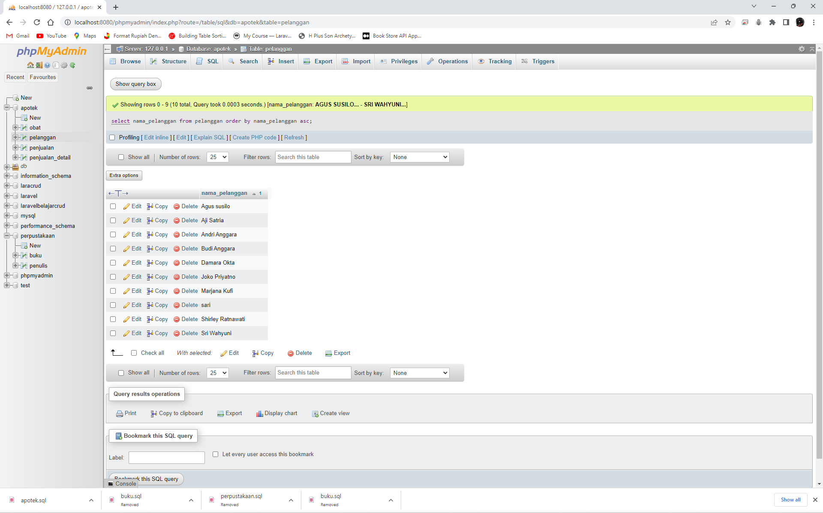

select nama_pelanggan, umur from pelanggan order by umur desc;

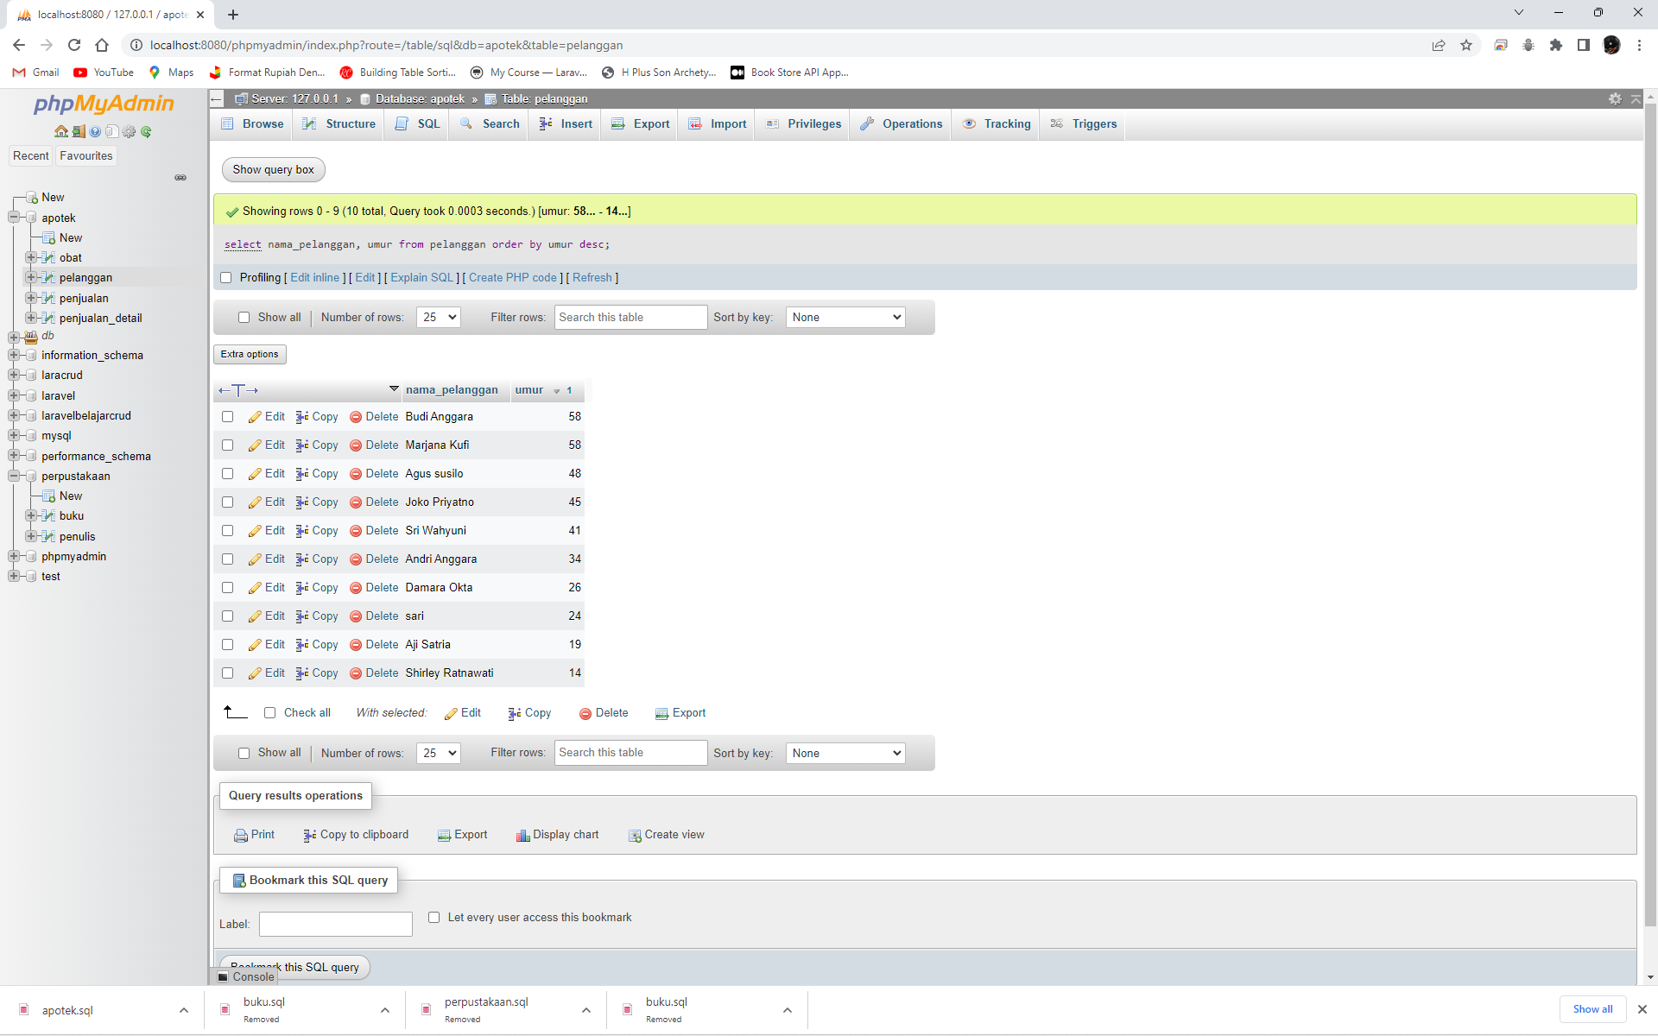

select nama_pelanggan, alamat from pelanggan where alamat like '%Yogyakarta%';

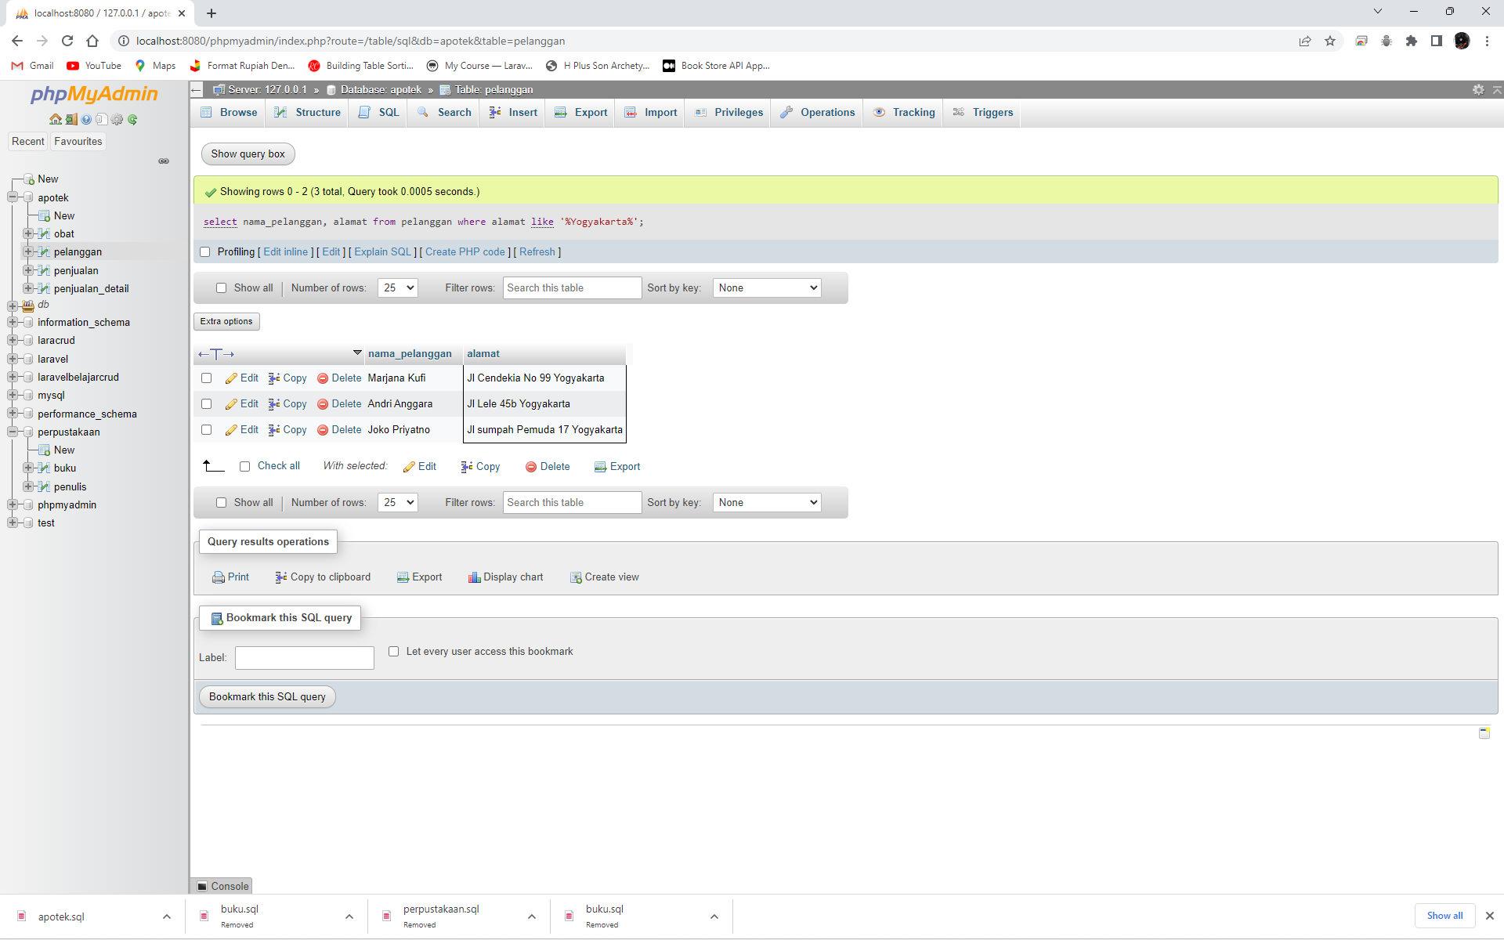

select nama_pelanggan, alamat from pelanggan where alamat like '%Bekasi%';

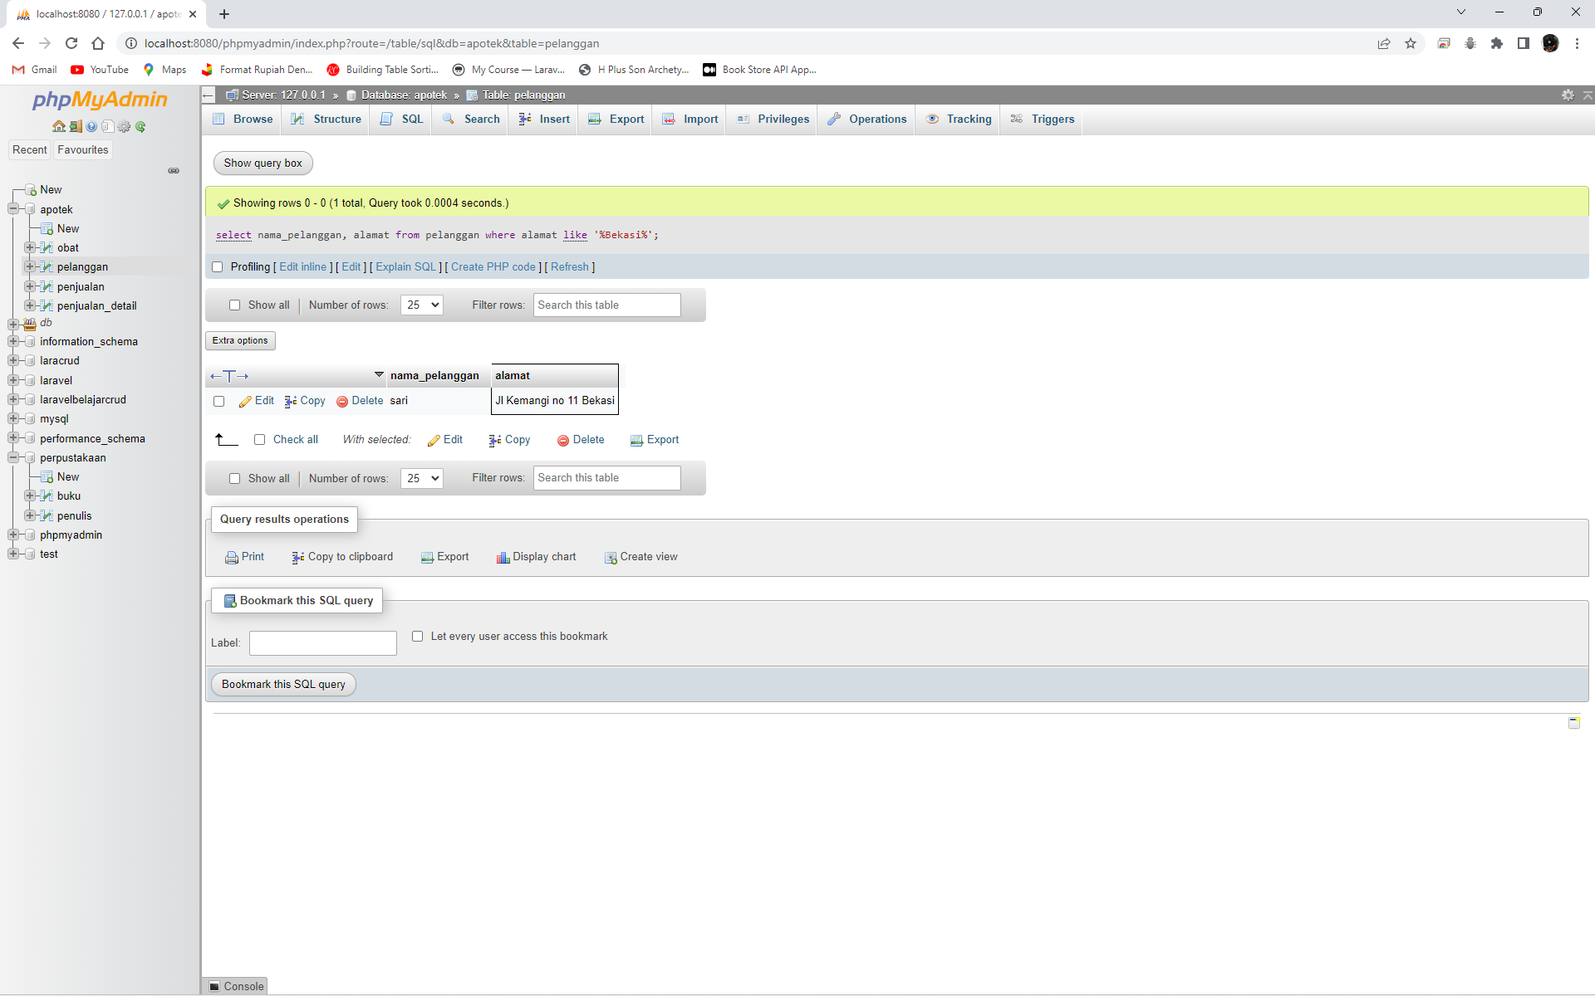

select count(jk) as Pria from pelanggan where jk = 1;

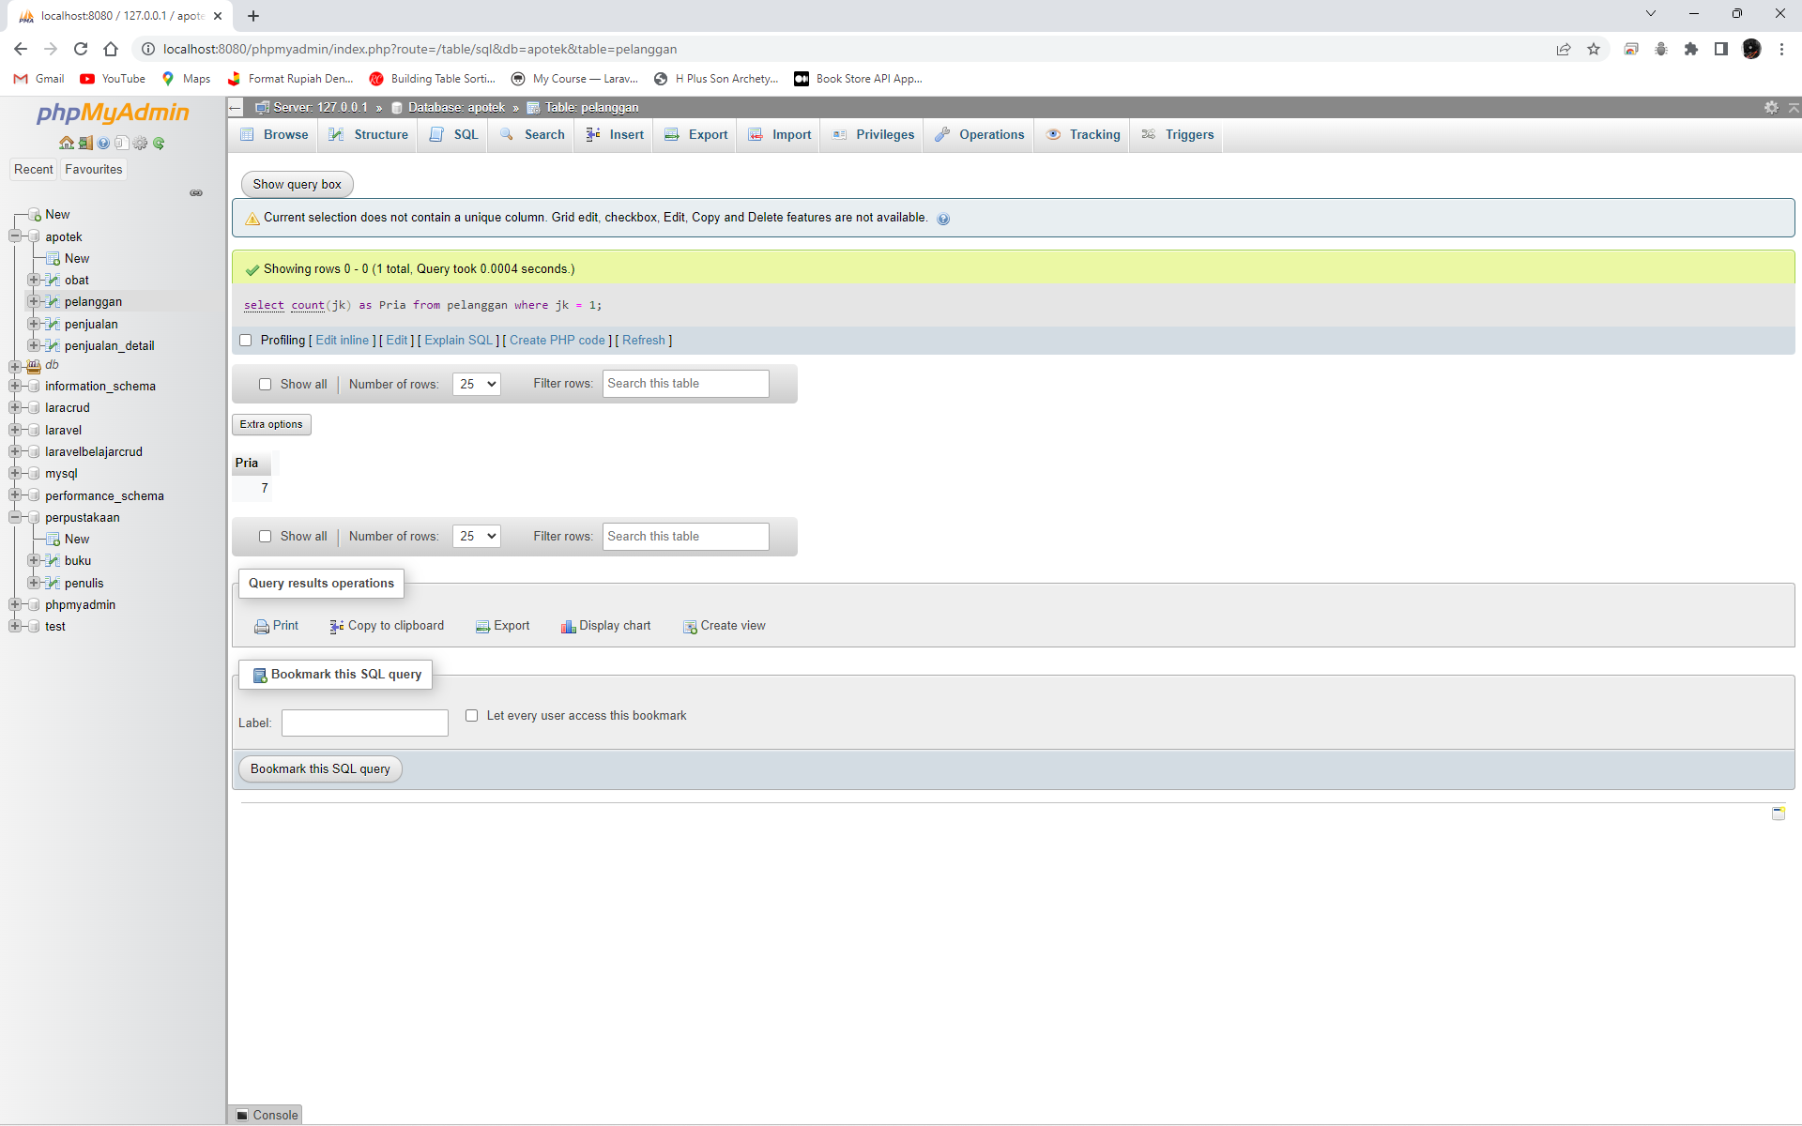

select count(jk) as Wanita from pelanggan where jk = 2;

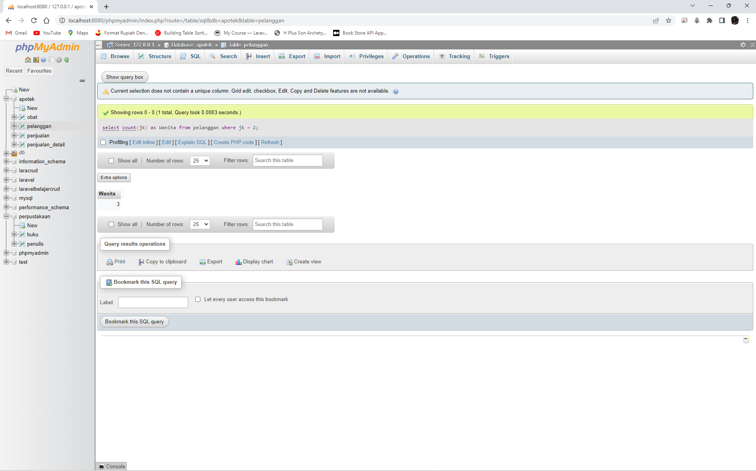

select nama_pelanggan, umur from pelanggan where umur between 20 and 30;

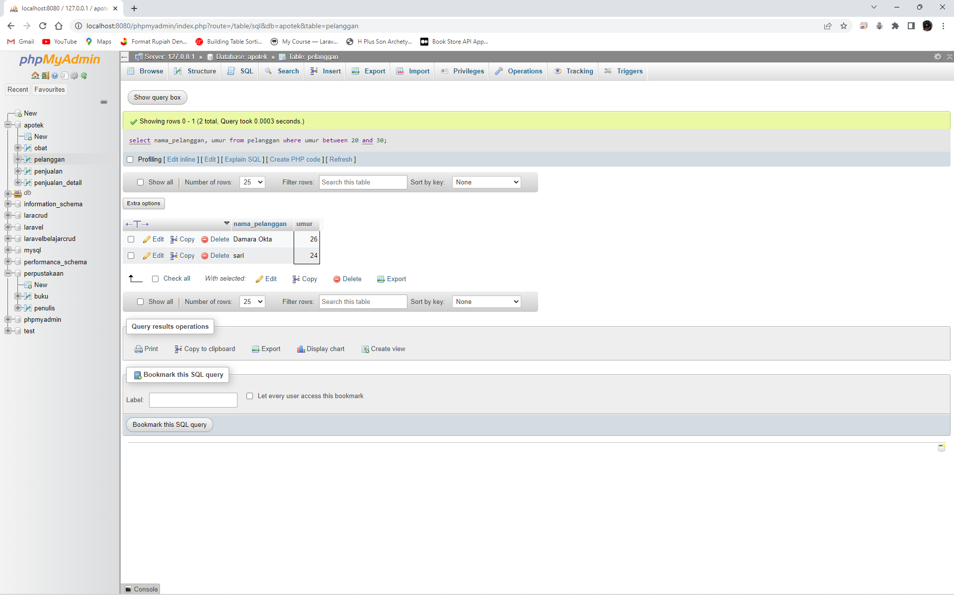

select nama_pelanggan from pelanggan where nama_pelanggan like 'Angga';

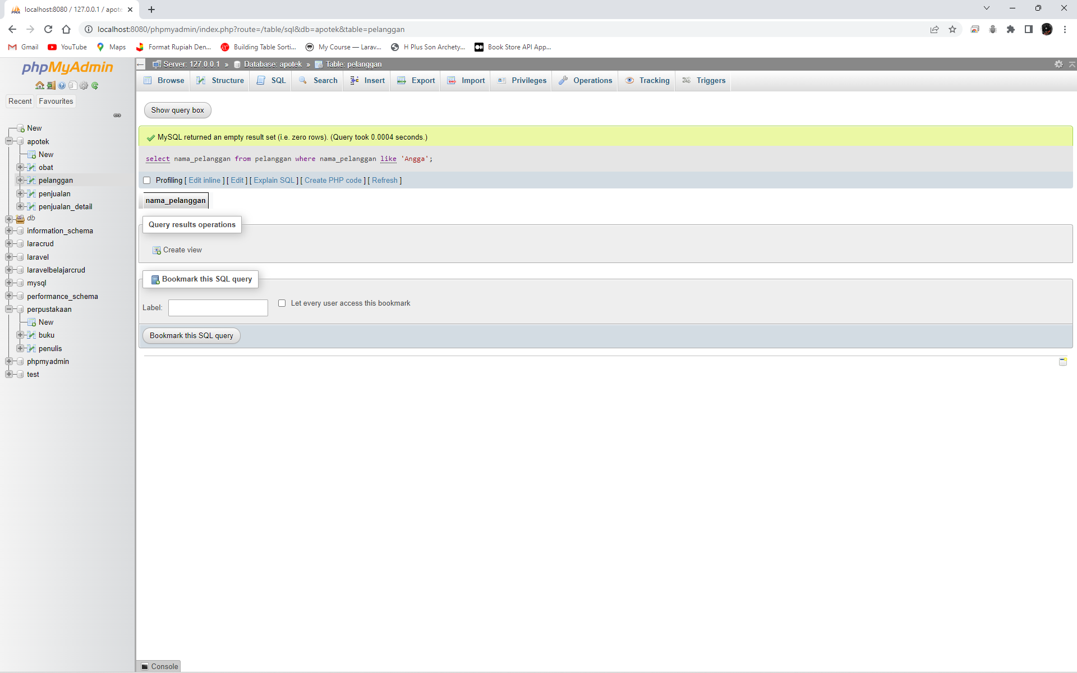

select nama_pelanggan from pelanggan where nama_pelanggan like '%Angga%';

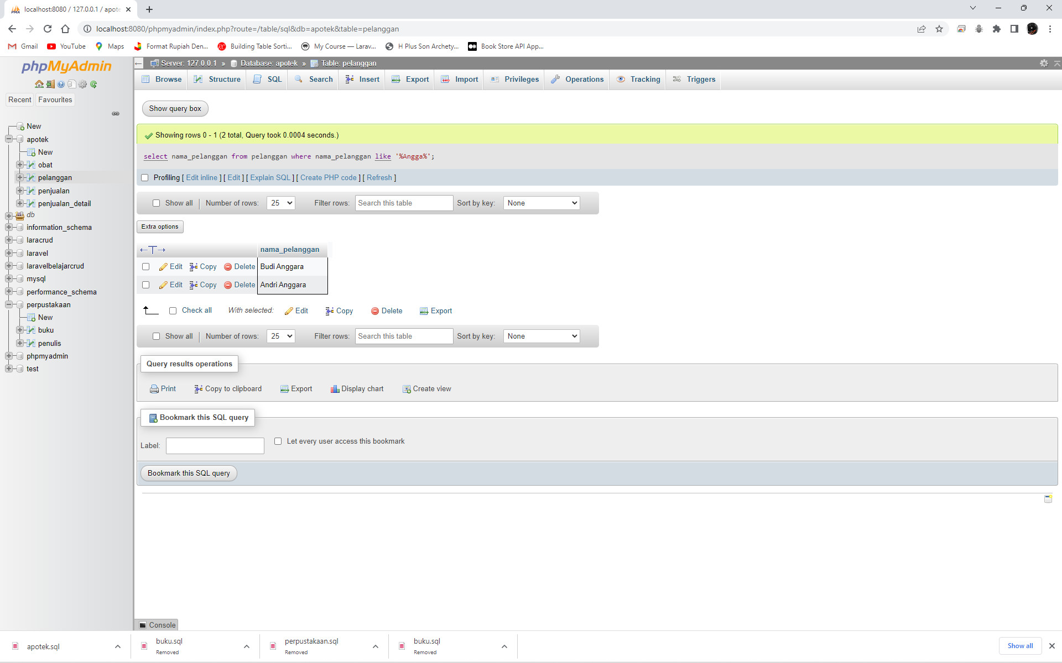

select count(nama_pelanggan) as jumlah_pelanggan from pelanggan;

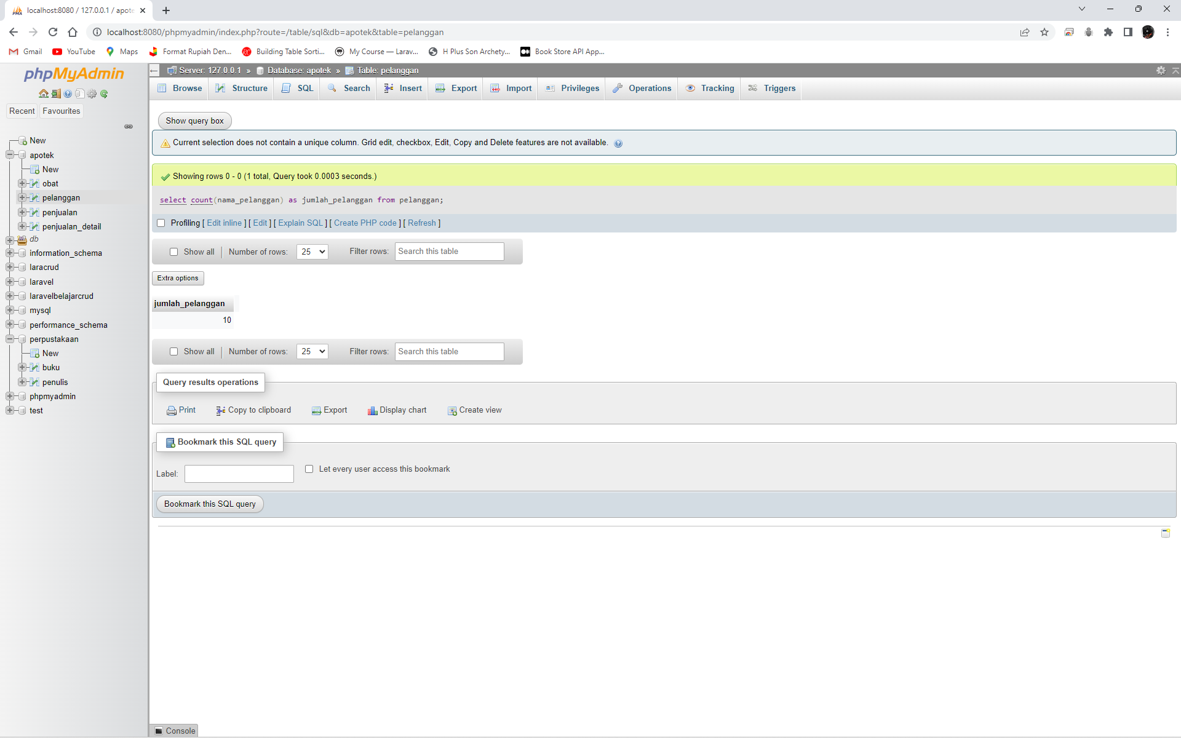

>>>>>>>>>>>>>>>>>>>>>>>>>>>>>>>>>>>>>>>>>> Revisi <<<<<<<<<<<<<<<<<<<<<<<<<<<<<<<<<<<<<<<<<<

select nama_pelanggan from pelanggan where umur < 20;

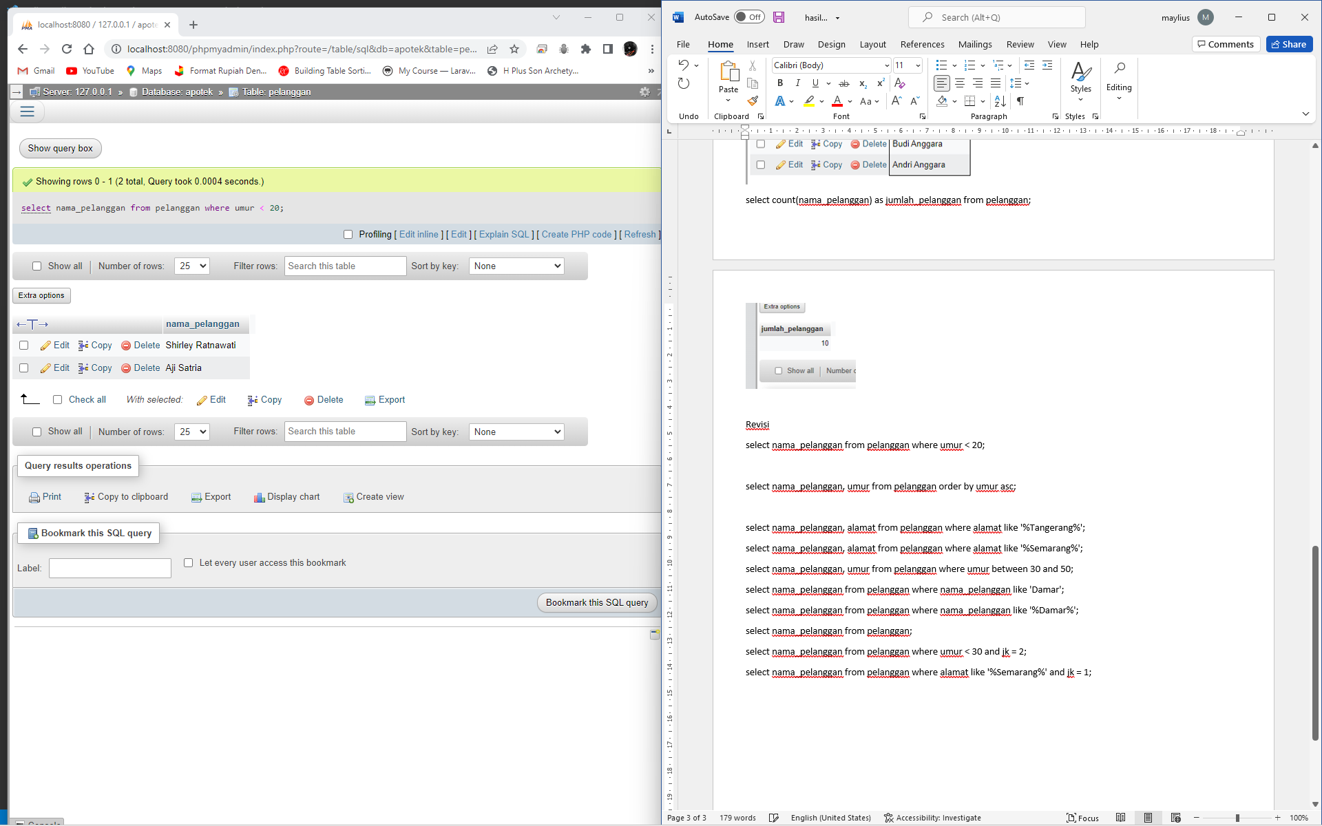

select nama_pelanggan, umur from pelanggan order by umur asc;

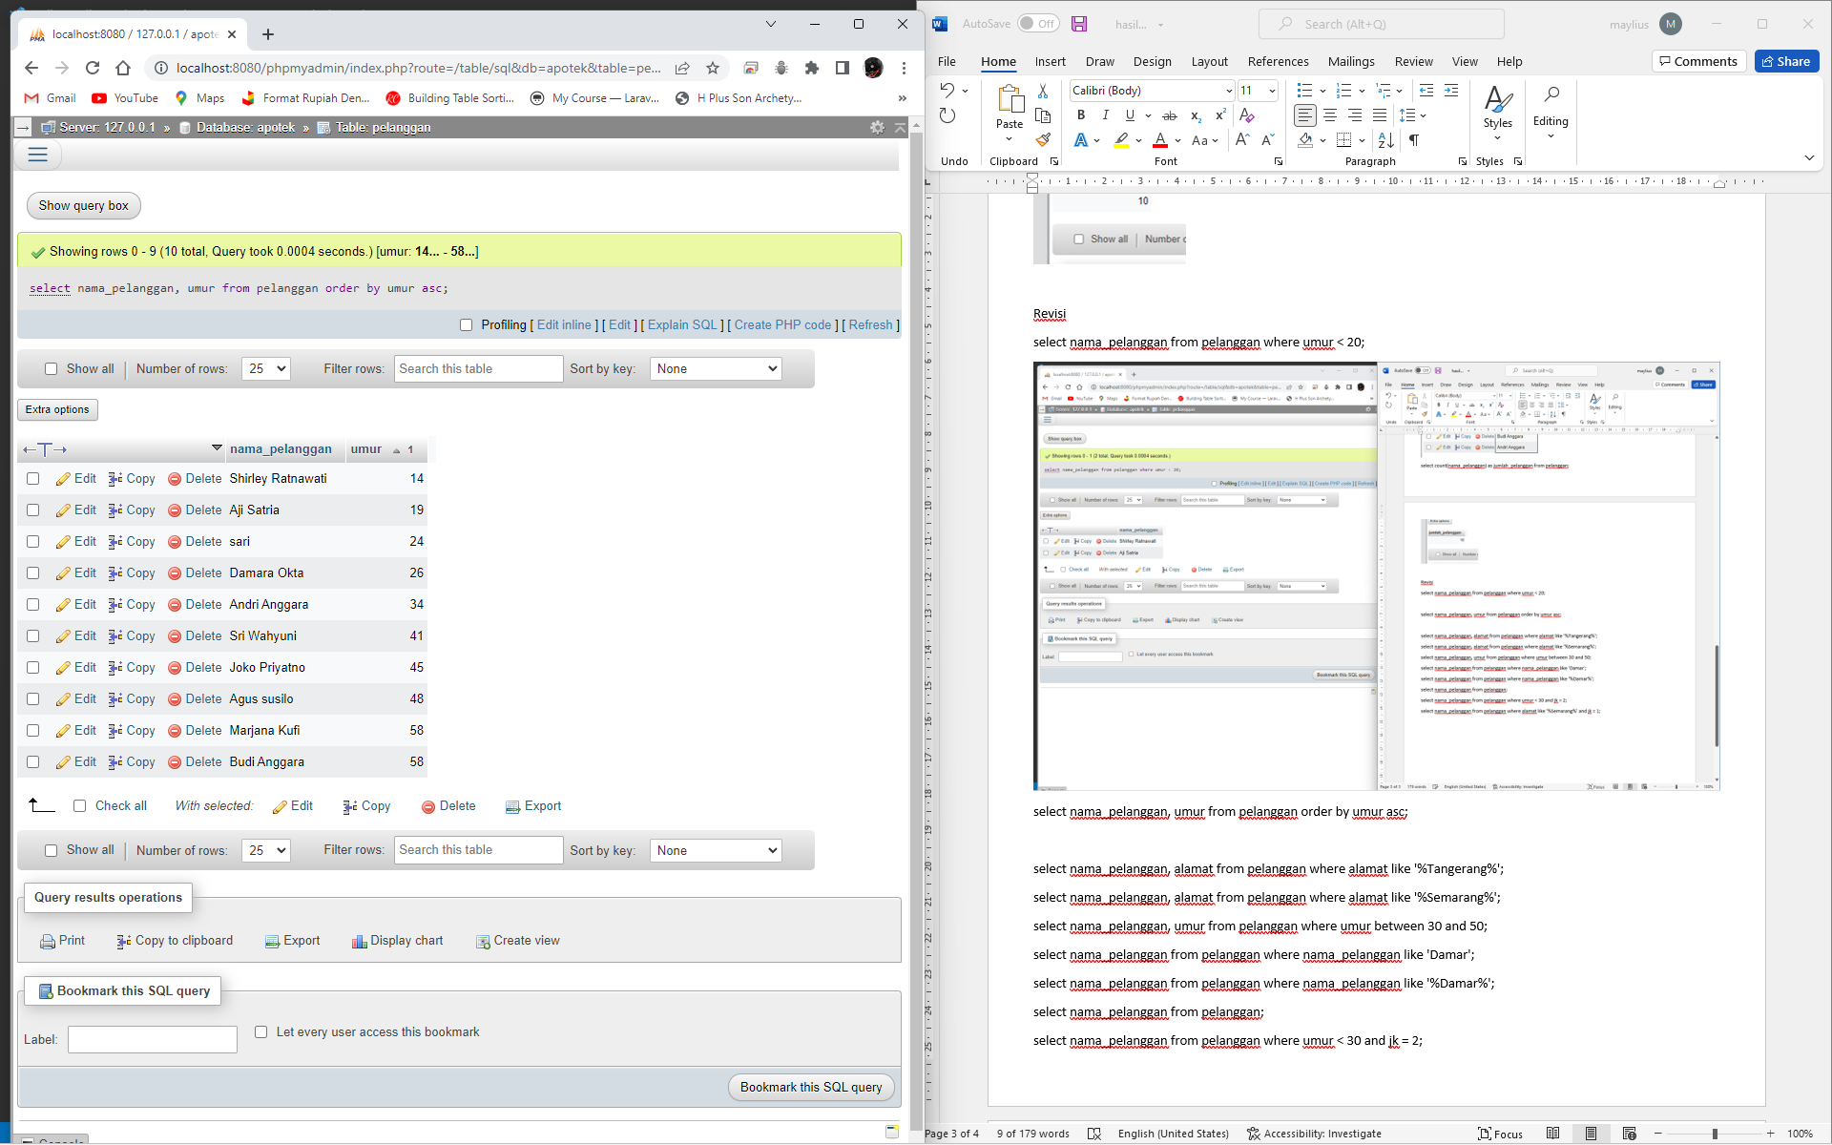

select nama_pelanggan, alamat from pelanggan where alamat like '%Tangerang%';

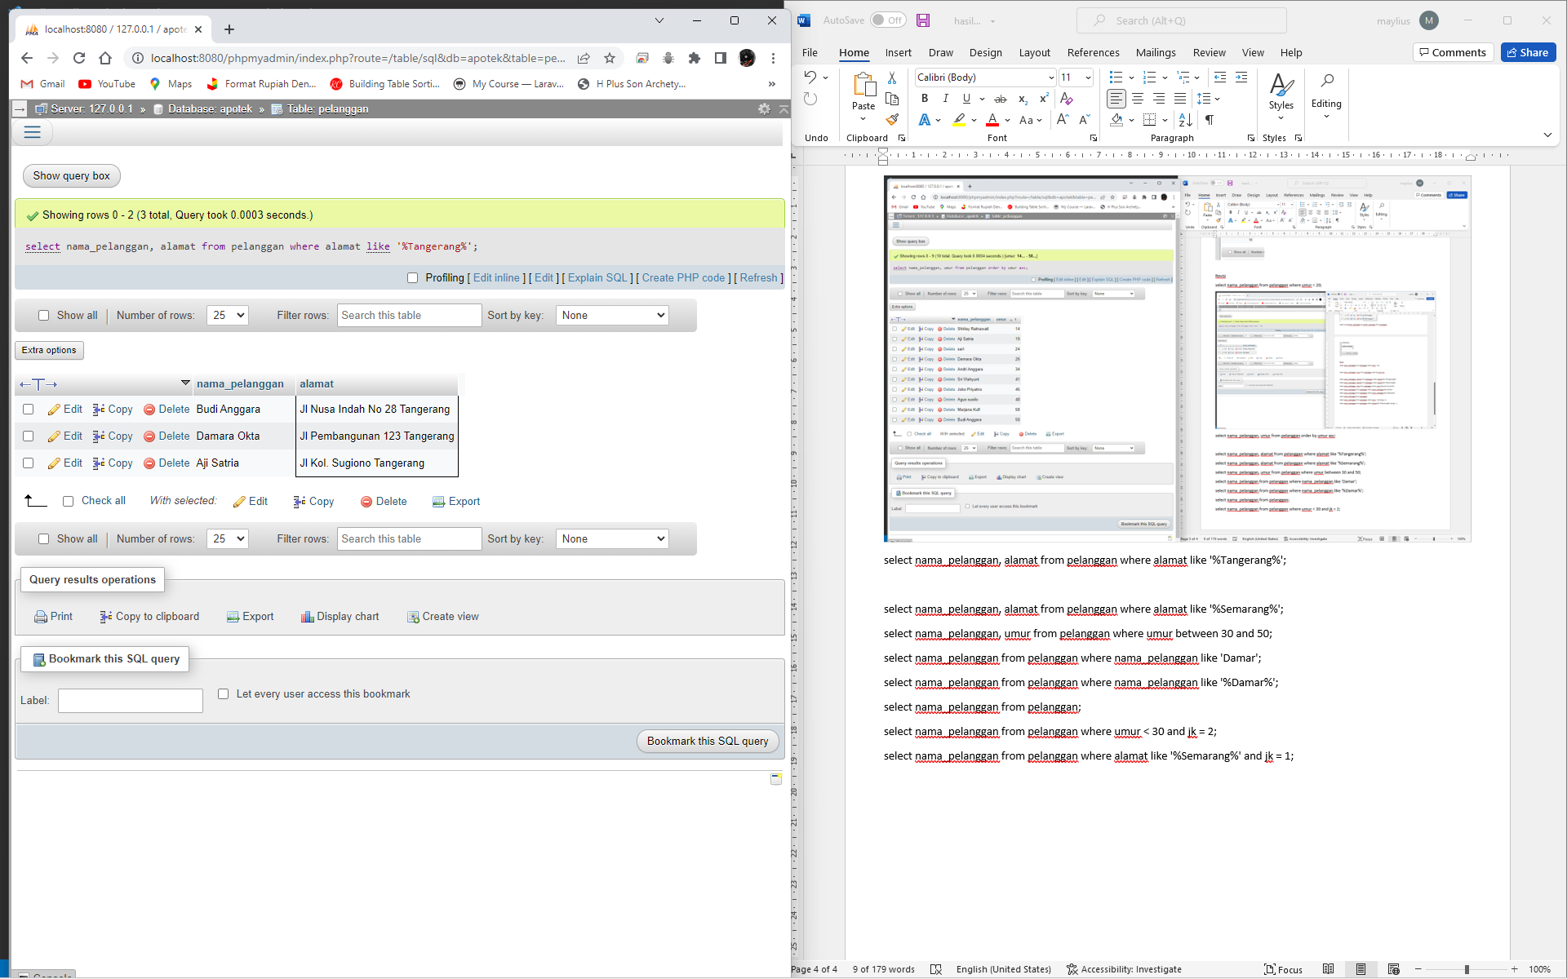

select nama_pelanggan, alamat from pelanggan where alamat like '%Semarang%';

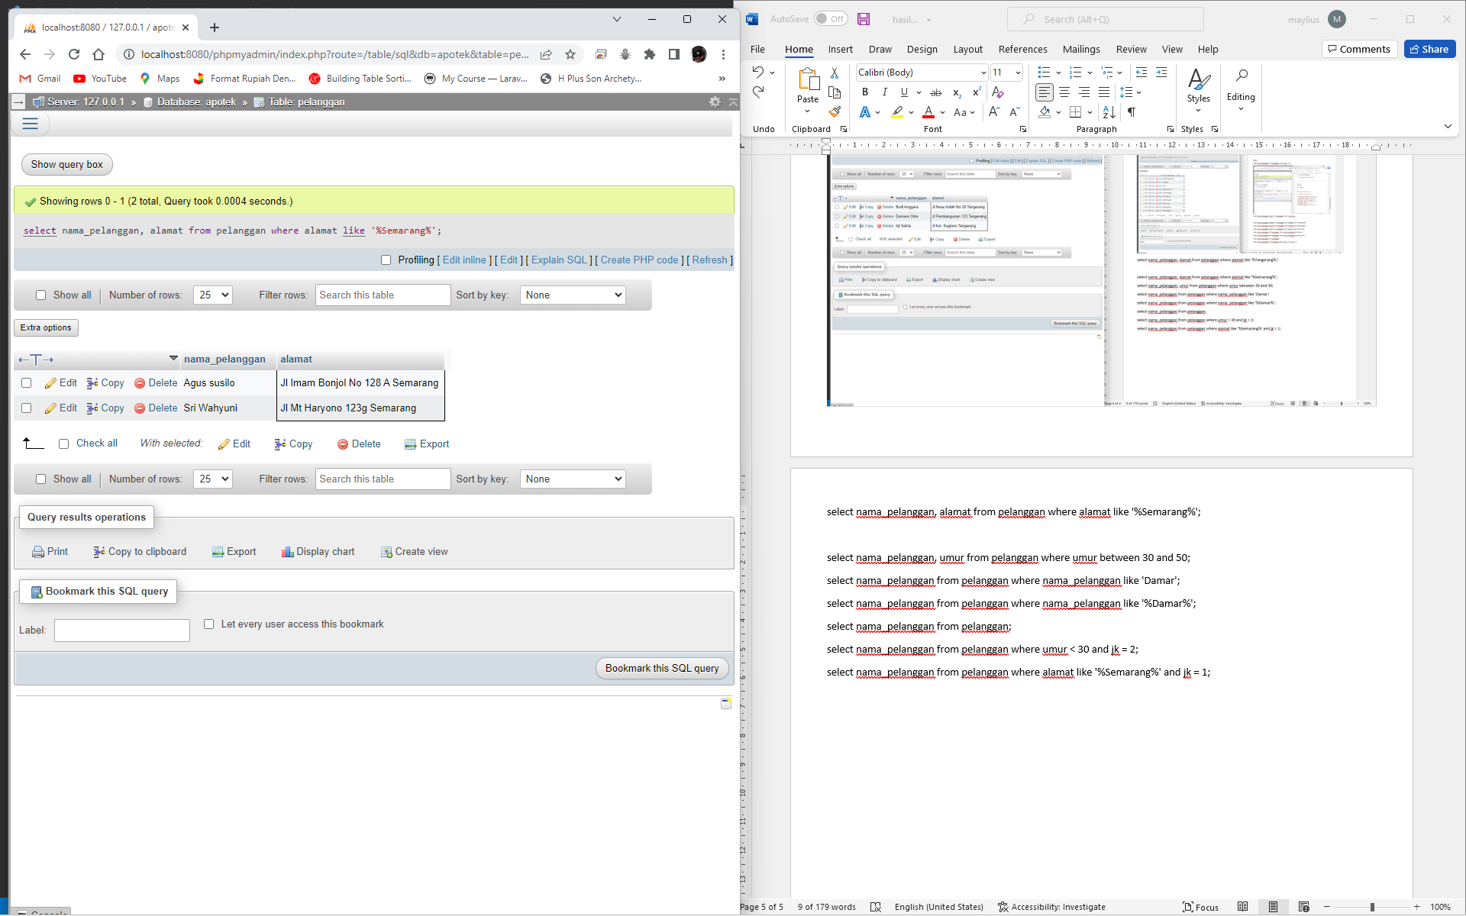

select nama_pelanggan, umur from pelanggan where umur between 30 and 50;

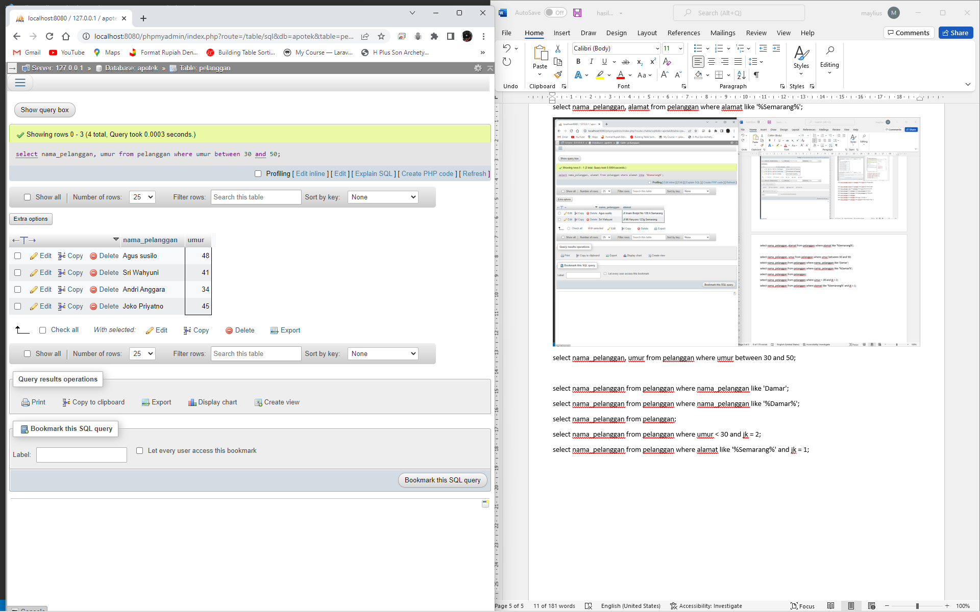

select nama_pelanggan from pelanggan where nama_pelanggan like 'Damar';

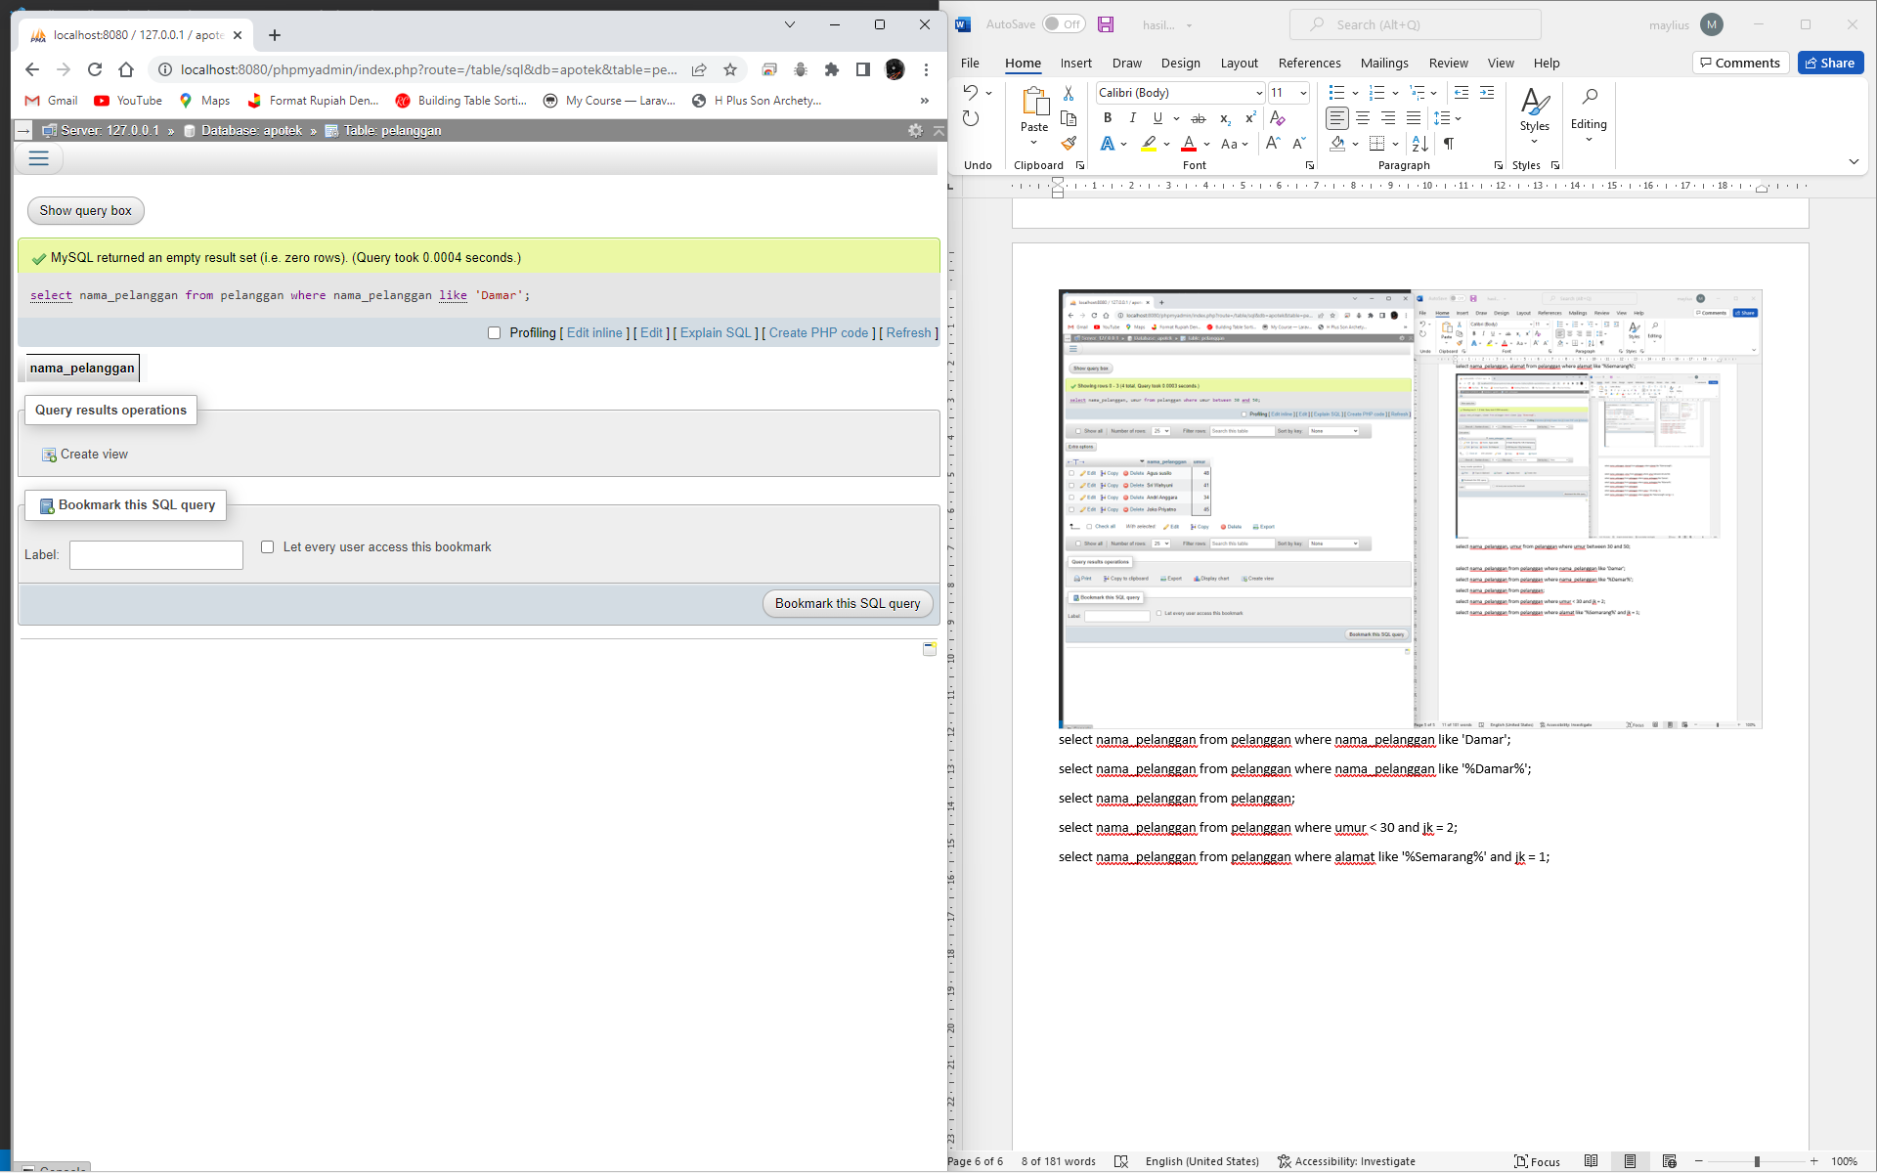

select nama_pelanggan from pelanggan where nama_pelanggan like '%Damar%';

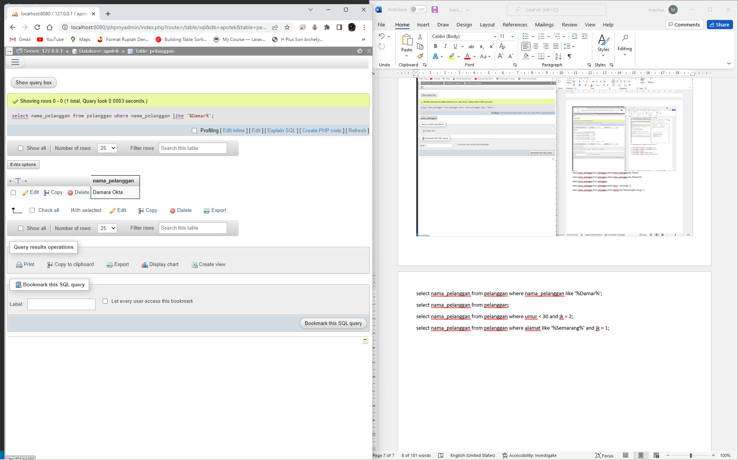

select nama_pelanggan from pelanggan;

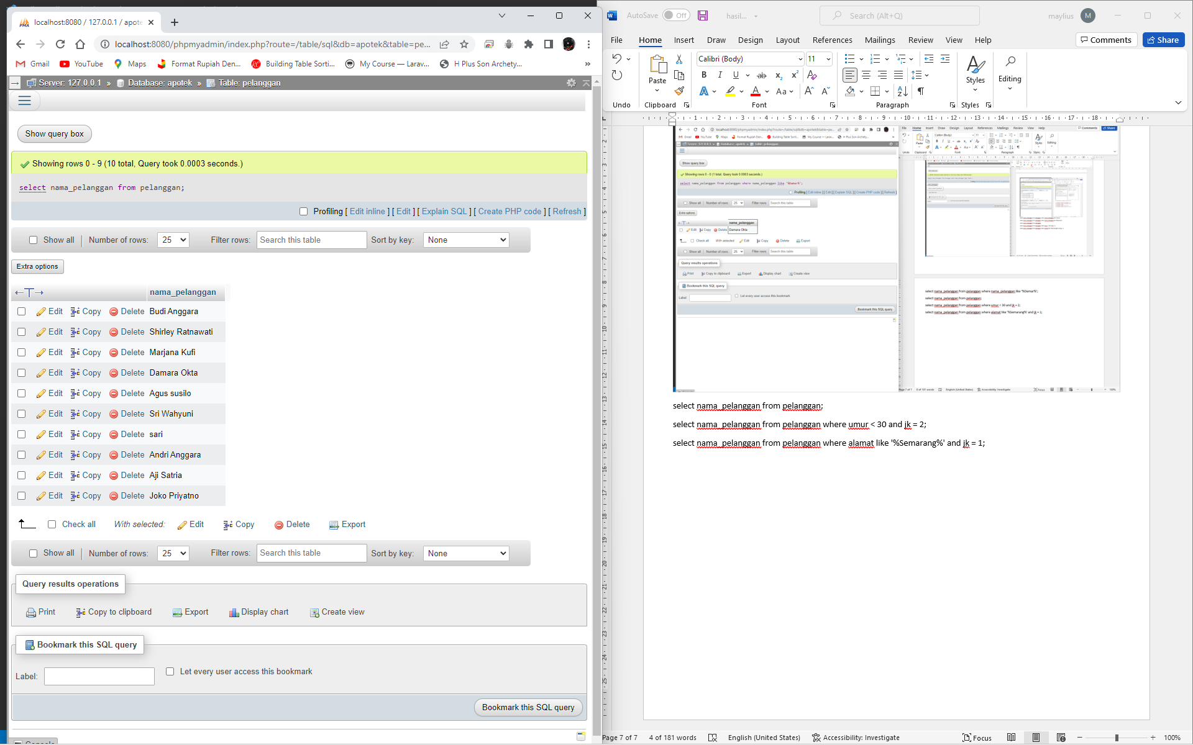

select nama_pelanggan from pelanggan where umur < 30 and jk = 2;

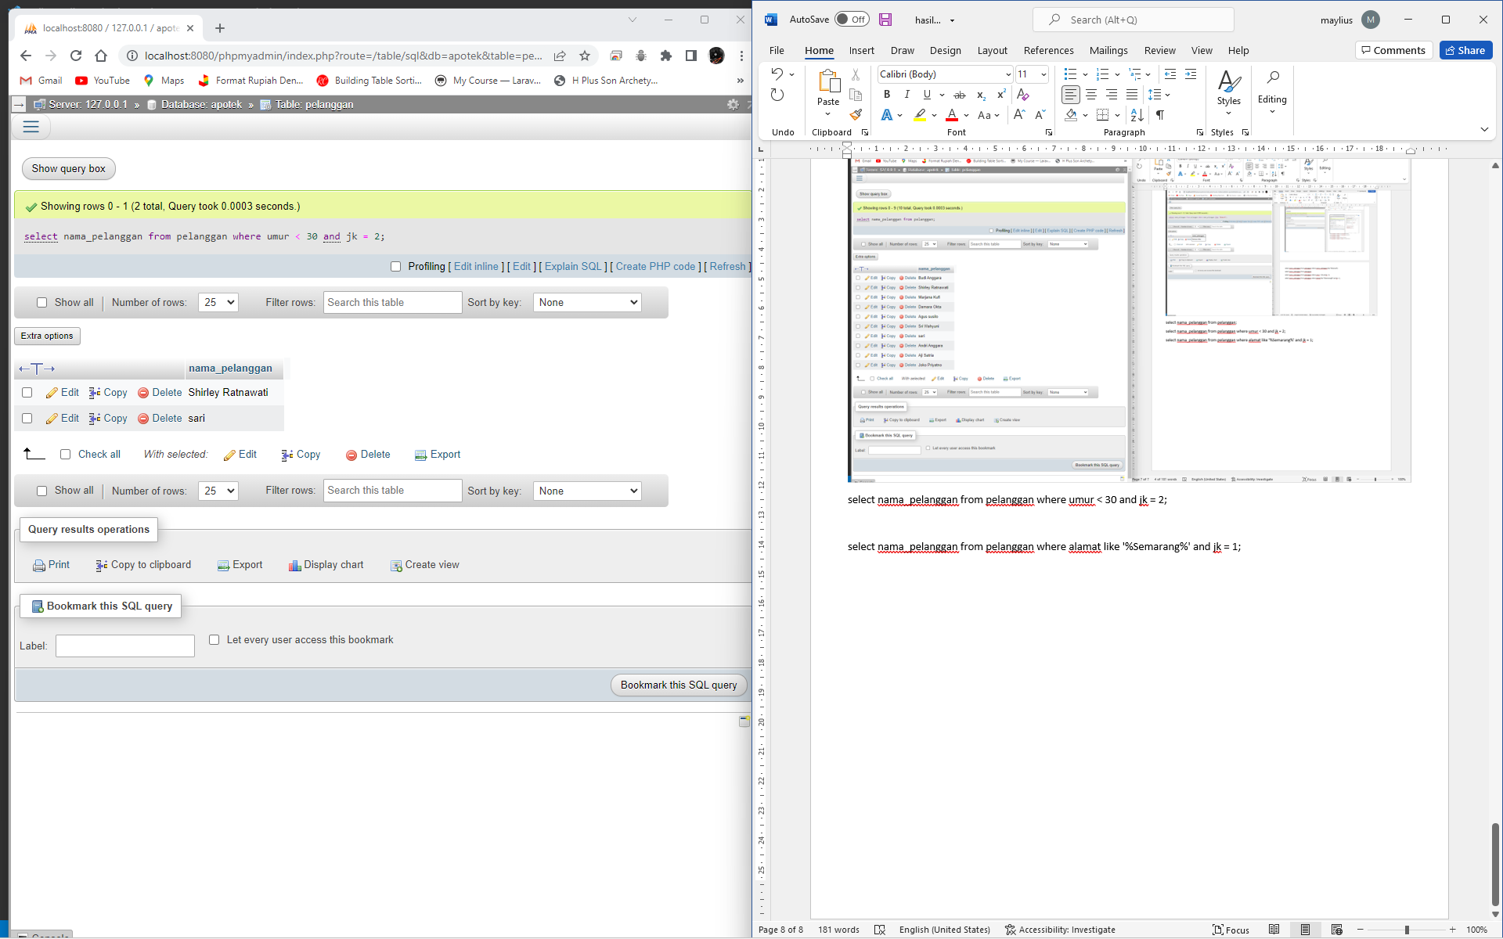

select nama_pelanggan from pelanggan where alamat like '%Semarang%' and jk = 1;

